**10031873@mail.tycg.gov.tw**

**寄件者:** Sister Cities International <info@sistercities.org>

**寄件日期:** 2025年2月14日星期五 下午 9:00

**收件者:** 10031873@mail.tycg.gov.tw

**主旨:** SCI - 2025 Young Artists and Authors Showcase

**郵件標幟: 標幟狀態:**

待處理

已標幟

Email not showing up correctly? View this email in your browser

1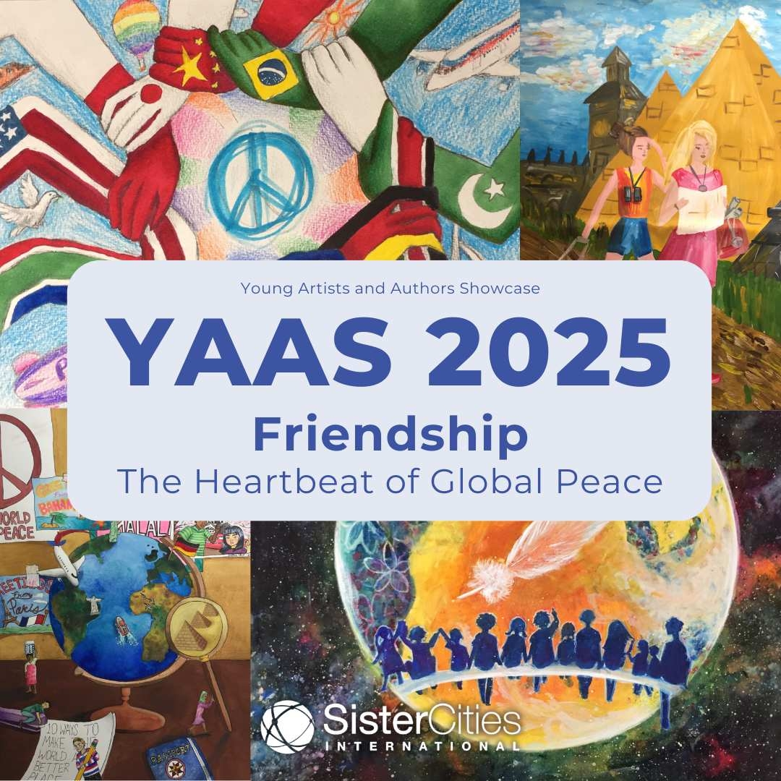

**DEADLINE TO APPLY: APRIL 1, 2025**

Sister Cities International is proud to present the 2025 Young Artists and

Authors Showcase, inviting youth from around the world to express their

creativity through the theme **“Friendship: The Heartbeat of Global**

**Peace.”** This year’s theme highlights the **power of friendship to foster**

**understanding**, **collaboration**, and **peace across borders.**

By participating in this inspiring competition, young creators will have the opportunity to share their vision of a peaceful world and contribute to the

international dialogue about the importance of building friendships across

nations. Winning entries will be featured in Sister Cities International’s global

network, inspiring communities and leaders worldwide.

**VISIT OUR WEBSITE FOR MORE**

**INFORMATION**

This year, we are hosting two separate competitions based on age groups. Applicants aged 12-14 will compete in one showcase, while those aged 15-18

will compete in another. In each age group and each art medium, there will be a

first, second, and third place winner.

**CLICK HERE TO APPLY**

Awards will be given out to YAAS winners who place 1st, 2nd, and 3rd place in

each category and in each age showcase.

**1st Place: $1,000**

1. **Place: $500**
2. **Place: $250**

2

**VIEW 2024 WINNERS**

*Copyright © 2025 Sister Cities International, All rights reserved.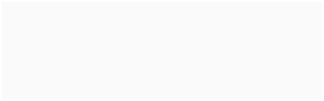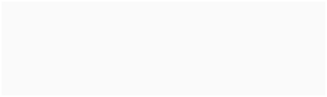*

**Our mailing address is:**

1012 14th Street NW Suite 1400

Washington, DC 20005

Want to change how you receive these emails?

You can update your preferences or unsubscribe from this list.

3

SCI YAAS 2025 來信翻譯

青少年藝術家及作家展演（YAAS）2025 友誼－全球和平脈動

截止日期：2025年4月1日

國際姊妹協會很榮幸為您介紹 2025 年青少年藝術家及作家展演徵獎活動，

邀請全球青少年以「友誼－全球和平脈動」為主題展現其創意。今年主題強調以友誼促進跨國界的理解、合作及和平的力量。透過參與本次鼓舞人心的競賽，年輕創作者將有機會分享他們對和平世界的願景，並為建立跨國友誼重要性的國際對話做出貢獻。獲獎作品將在國際姐妹市協會的全球網絡中展出，以啟發世界各地的社區與領導者。

今年，我們將根據年齡組別舉辦兩項獨立的競賽。12-14 歲的申請者將參加

1 組展演活動，而 15-18 歲的申請者將參加另1 組。在每個年齡組別及每項藝術競賽類別中，都將產生第1、第2及第3名獲獎者。

我們將頒獎予每項類別及每個年齡層展演活動中，獲得第1、第2及第3名的參與者。

第1名：1,000美元

第2名：500美元

第3名：250美元

YAAS 2025

**YOUNG ARTISTS AND AUTHORS**

**SHOWCASE**

**Friendship: The Heartbeat of Global Peace**

DEADLINE TO APPLY: APRIL 1, 2025

Sister Cities International is proud to present the 2025 Young Artists and Authors Showcase, inviting youth from around the world to express their creativity through the theme **“Friendship: The Heartbeat of Global**

**Peace.”** This year’s theme highlights the **power of friendship to foster**

**understanding**, **collaboration**, and **peace across borders.**

Open to artists, writers, photographers, and musicians aged 12-18, the

Showcase provides a unique platform to explore how global friendships can

drive positive change and bridge cultural divides. Submissions will be

accepted in various mediums, including visual art, essays, poetry, and music.

By participating in this inspiring competition, young creators will have the

opportunity to share their vision of a peaceful world and contribute to the

international dialogue about the importance of building friendships across

nations. Winning entries will be featured in Sister Cities International’s global

network, inspiring communities and leaders worldwide.

**2024 Classic Art Showcase Winner**

“Reflect,” Loralee House, Norfolk Sister City Association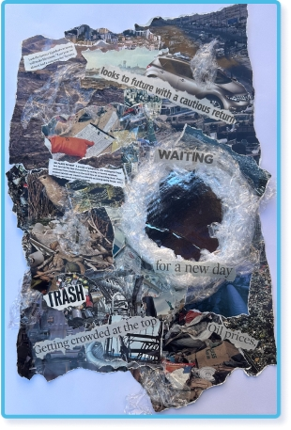

**Click Here to Apply**

What is YAAS?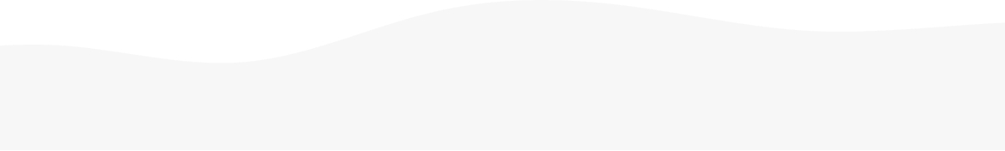

The Young Artists and Authors Showcase (YAAS) is an annual contest that encourages youth worldwide to express the mission of Sister Cities International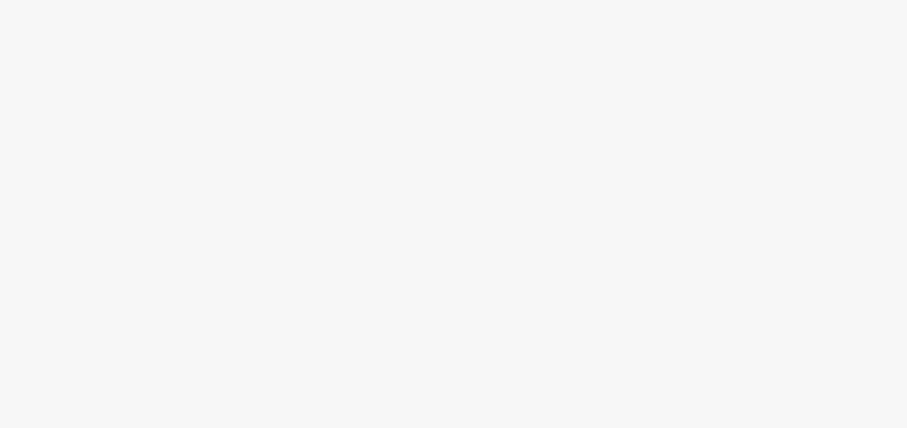

through original artwork, literature, photography, and music.

**We encourage our youth to be creative and examine all aspects of this year’s theme, including but not limited to :**

**How can friendship**

**transcend cultural,**

**language, or national**

**barriers to create lasting**

**peace?**

**What symbols or**

**imagery represent the**

**connection between**

**friendship and global**

**harmony?**

**In what ways can friendships between**

**individuals or**

**communities inspire**

**positive change in the**

**world?**

**How do acts of kindness**

**and understanding**

**between friends**

**contribute to a more**

**peaceful global society?**

**What does the “heartbeat” of global**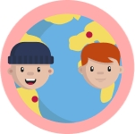

**peace look like in your**

**personal experience of**

**friendship across**

**borders?**

Age **Categories**

This year, we are hosting two separate competitions based on age groups. Applicants aged 12-14 will compete in one showcase, while those aged 15-18 will compete in another. In each age group and each art medium, there will be a first, second, and third place winner.

**Prizes**

Grand prize winners in each age group and each art medium will receive a $1,000 prize. Second place winners will receive a $500 prize, and third place winners will be awarded a $250 prize.

This year, we are reintroducing an in-person aspect to the competition. Winners will be required to send framed versions of their original artwork to the Sister Cities International National Office in Washington, DC, at their own expense. Further details will be shared with winners in early summer 2025. The winning artwork will also be featured on the Sister Cities International website after the announcement.

All cash prizes for the 2025 winners **must be claimed within one month** of receiving notification of their win.

**Submission Categories**

Classic Art Showcase Digital Art Showcase Essay Showcase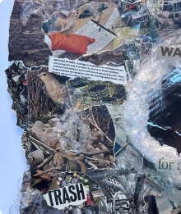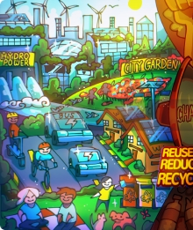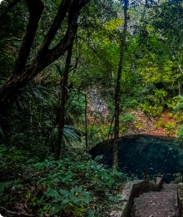

Poetry Showcase Original Music Photography Showcase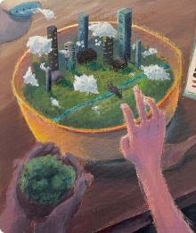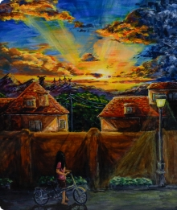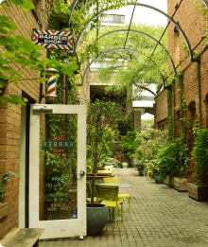

**Additional Info**

**Eligibility Criteria**

Please read the following details carefully. All additional questions can be directed to **youth@sistercities.org**.

Students must be between 12 and 18 years of age at the time of the April 1, 2025 deadline.

The student must be affiliated with and have a direct point of contact with a dues-paying member of Sister Cities International or an international

community partnered with a dues-paying member.

Each dues-paying member city may submit up to five (5) entries per category, per sister city, and per age group. International community partners are

also eligible to submit a maximum of five (5) entries per category and age group.

Each student can only submit one art piece across the whole YAAS competition.

All entries must conform to the Sister Cities International policy on plagiarism found here.

All entries must be submitted and received through the online application by April 1, 2025, 11:59PM ET.

**Frequently Asked Questions**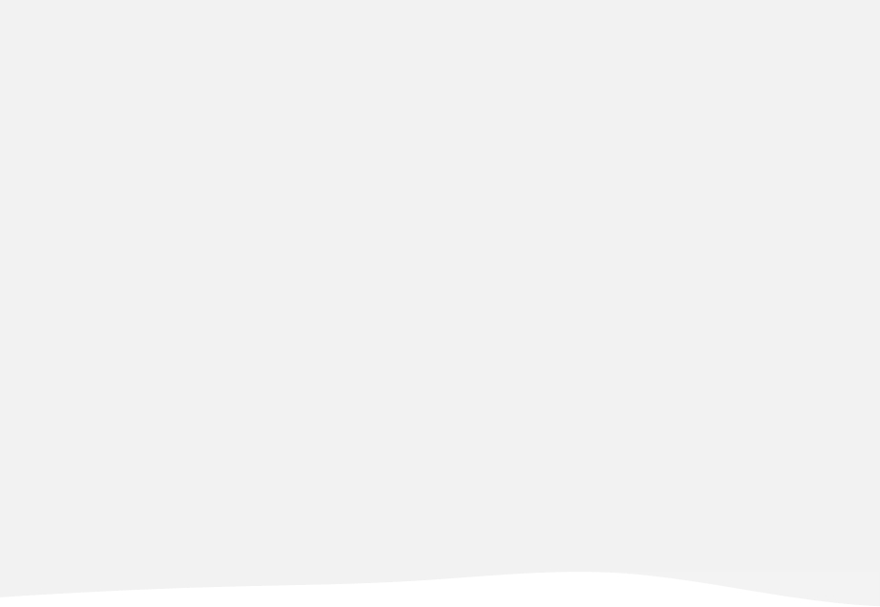

**I am an individual located in X country/city, am I automatically a part of a Sister City organization?**

No. If you have not contacted your local sister city organization before, you are not automatically part of their network. If you have attended any events through their local programming, you might be in their network. However, all sister city organizations have their own membership procedures. There might be fees and other conditions for being part of their network. Therefore, please contact your local organization to learn more about your current status.

**Is there a sister city organization near me and how do I find my Sister City program information?**

**I didn't know I had to be a part of a sister city program to submit my artwork. Can I still submit without their approval?**

**I am interested in hosting a competition within my local sister city program, how do I do this?**

**Is my school teacher my sister city contact?**

**Can I provide my school email address when I am filing out the submission form?**

**Do I need to send my artwork to the SCI National Office in Washington, DC?**

**What do you mean by five submissions per category, per sister city?**

Congratulations 2024 YAAS Winners

**2024 Winner**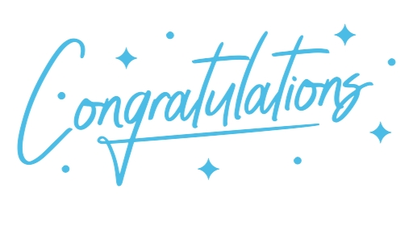

國際姊妹市協會

2025青少年藝術家及創作者展演 友誼－全球和平脈動徵獎

截止日期：2025年4月1日

連結：https://reurl.cc/WAn9z9

聯絡Email：youth@sistercities.org.

|  |  |
| --- | --- |
| 青少年藝術家及創作者展演（YAAS）係鼓勵全球青少年以藝術創作、文學攝  影及音樂，展示國際姊妹市協會所肩負任務使命之年度競賽。 | |
| 如何評比  參賽作品將圍繞年度主題進行評審，評分標準包括創意度、構圖以及主題詮釋。 | 獎項  各類別首獎1,000元美金、貳獎500 元美金及參獎250元美金。得獎者作品將於青少年領導峰會宣布後，展示於國際姊妹市協會網站。  備註  獲獎者須自費將原創作品裝裱版本寄送至位於美國華盛頓特區之國際姊妹市全國辦公室參展。 |
| 資格及指南  學生須向其會員城市確認參與資格。確認後報名提交參賽申請。  參賽學生年齡於2025年4月1日時之年齡必須介於12至18歲。 | |
| 古典藝術   * 媒材不拘：油彩、壓克力顏料、炭筆、水彩以及色鉛筆。數位創作係另一種類別。 * 作品照片請以下列格式上傳：   a.jpeg/.jpg or.png format。 | 數位藝術   * 提交作品至大1350X1080px。 * 不接受動態藝術作品。 * 作品大小至少要有   1350X1090px。   * 作品照片請以下列格式上傳：   a.jpeg/.jpg or.png format。 |
| 攝影   * 攝影作品允許有限度的數位調整。允許的編輯包含 (但不限   於) 濾鏡和光線調整。欲知更多細節，請參閱網站。   * 僅接受2D無框作品。 * 作品照片請以下列格式上傳：   a.jpeg/.jpg or.png format。 | 原創音樂   * 只接受音訊作品格式，不得提交影片格式。 * 提交作品長度不得超過4分鐘。 * 投件作品須為原創，不得翻唱或改編既有作品。 * 提交作品僅限使用MP3格式。 |
| 文學創作   * 文章可以是符合內容指南的創意 | 詩詞   * 提交作品需使用英文寫作。 |

|  |  |
| --- | --- |
| 寫作、散文、軼事和其他文字作  品。   * 提交作品需使用英文寫作。 * 字數不得超過 500 字。 * 學生必須上傳他們的檔案，格式為 .pdf 或 .doc | * 詩詞不得超過200字。 * 學生必須上傳他們的檔案，格式為 .pdf 或 .doc。 |

參賽資格

若有疑問請洽：youth@sistercities.org

* 年齡資格：參賽學生於2025年4月1日截止日期年齡必須介於12至18 歲。
* 會員:參賽學生必須隸屬於國際姊妹市協會之繳納會費會員，或與該會員合作之國際社群，並且具有直接聯絡人。
* 提交作品數量：每個會員城市、姊妹市於每個年齡組別及競賽類別，最多可以提交5份參賽作品。
* 參賽作品限制：每位學生在本次競賽中僅能提交1件藝術作品。
* 剽竊政策：所有參賽作品必須符合國際姐妹城市協會關於剽竊的政策，詳情請參閱：https://sistercities.org/wp-

content/uploads/2022/12/Plagiarism-Policy.pdf 。

* 提交截止日期：所有參賽作品必須在2025年4月1日美國東部時間晚上11:59之前透過線上申請。

報名表中Sister City Program Information項次需填入國際姊妹市協會會員相關資訊，包含本市會員名稱及聯繫窗口等，請依照下列範例填寫: